Renju Problems Solving Competition
In this article we will first publish the answers of the first ten renju problems (problem1.doc) and after that we will also give you 10 new renju problems to solve. Take your time to check the given answers for the problem1.doc problems and compare them with the answers that you found by yourself. In some cases, perhaps you found another way to win, perhaps even shorter or more beautiful. In that case, please send me your answer and we can publish your idea in our website.

Answers for problem1.doc renju problems:
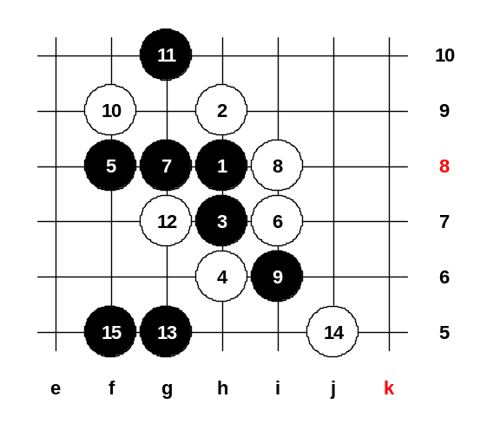
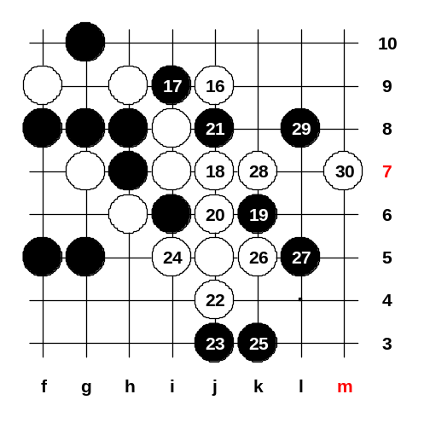
Problem 1: Although the white’s win here is not difficult, this problem still confuses many renju players because of it’s untraditional way of attacking. Many beginners tried to play 16-i9 here, but it is not correct move because of good defense 17-j9. The key of the attack is to make a VCF threat that allows to continue attack no matter where black stops. 16-j9 is the correct move, it is a VCF and it has a continuation of the attack no matter where black stops.

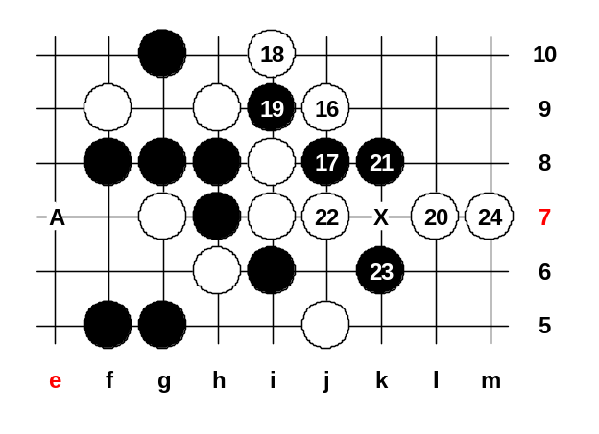
← Here black chose the most obvious defense move, but it lets white to set up another VCF threat that happens to be winning – black has no good 19th move to choose, all of them lose pretty fast.
Another 17th move is less obvious, but much stronger. Many people got stuck here while trying to search for white win. The most common mistake in their answers was 18-L7, that gives a good chance for black to have a counter-attack with 19-A. The correct way of winning is shown on the diagram.
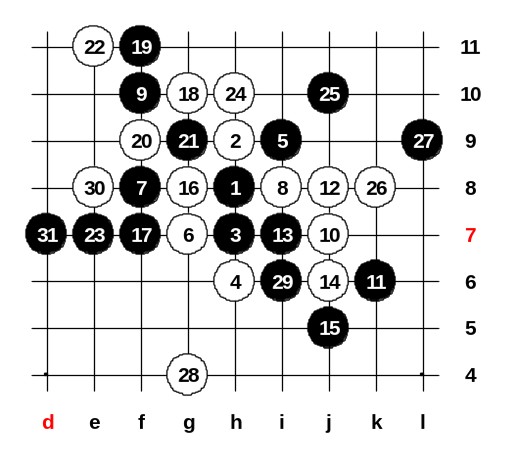
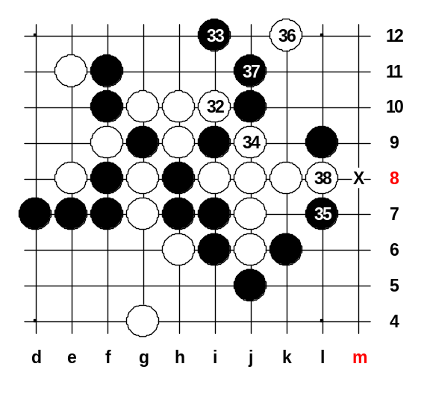
Problem 2: The position comes from the famous d8 opening variant. In the old times, white used to attack with 28-h11 and despite all efforts, white was unable to show sure win. Recently, about 2-3 years ago, Russian player Oleg Fedorkin showed white win in his renju magazine “Moscow Almanah”. The idea of the win is somehow simple, but even the world top players didn’t see this idea for a long time in the past. Moves 28 and 30 are nice start for the beautiful and simple win. With the move 32 white traps black into either 3x3 or 4x4. After the win was published in Russian renju magazine, almost all renju players stopped using that 23rd move. Nowadays they play 23-j10 which is very safe for black.

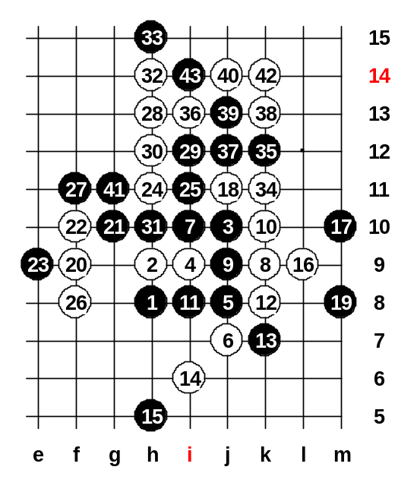

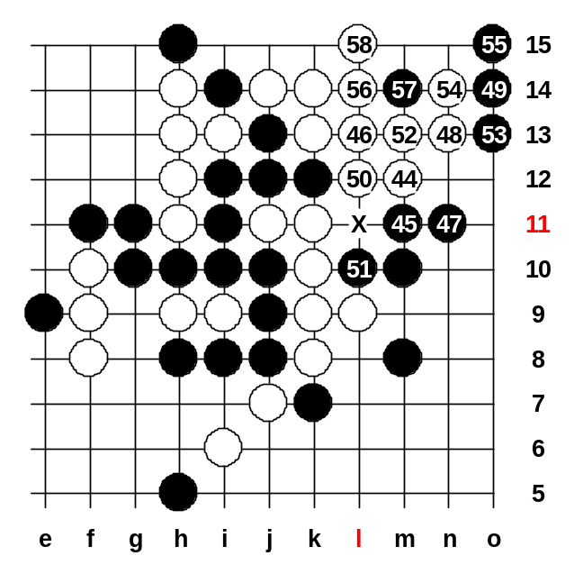
← Problem 3: This game was originally played between Bobkov (Russia) and me in 1992. After Bobkov’s big mistake, white got a chance for win. Since the win is quite beautiful and teaches a lot about taking advantage of black’s worst weakness (an overline), so I decided to publish it in the magazine as a renju problem. It is not too difficult, so most of the players found the win quite soon.
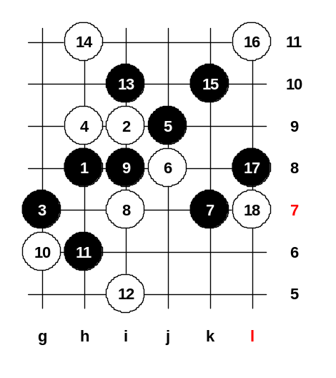
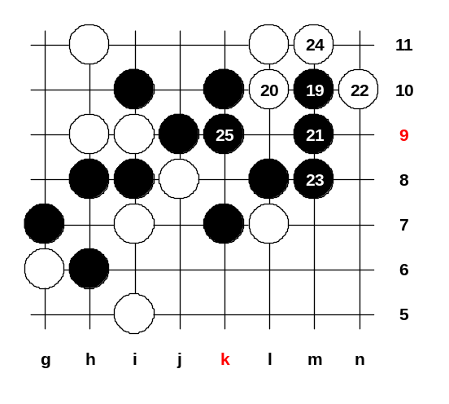
Problem 4: Those who ever studied the strongest 5th move in i11 opening, they probably recognized that the renju problem comes from i11 opening.

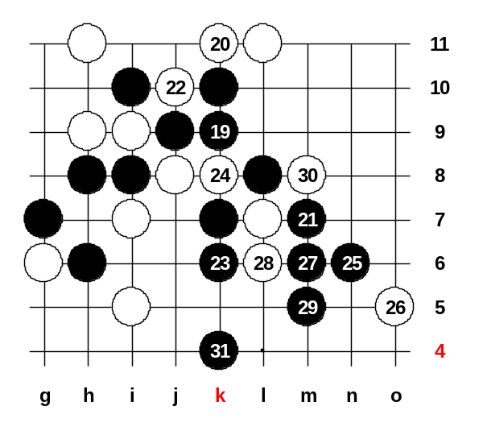
← This is the way the black can win here. The 19th move is very beautiful and gives black the possible sequence for winning.
However, there is another way to win, too. The win was found by CCK, he showed me the win steps one day in the Monday Renju Class. I was very surprised because I didn’t see that win myself before. It seemed impossible that black can win without using the m9 point, but CCK proved it was possible.
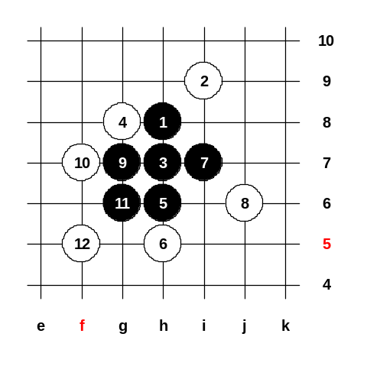

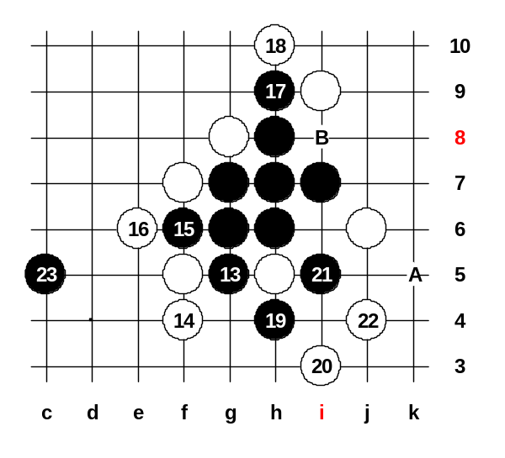
← Problem 5: There are two kinds of black wins here. One has been written in Russian renju book, another win was shown by Japanese player Makoto Yamaguchi. The way how Yamaguchi wins is much shorter and much more beautiful. That’s why I publish his way as the problem’s answer.
If 20-c7 then 21-22, 23-A.
If 22-f8 then 23-B.

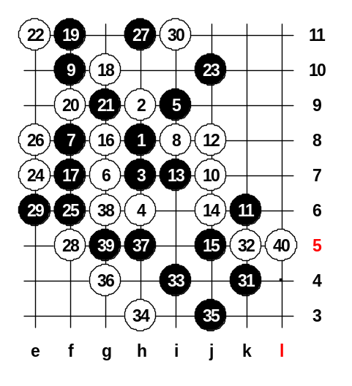
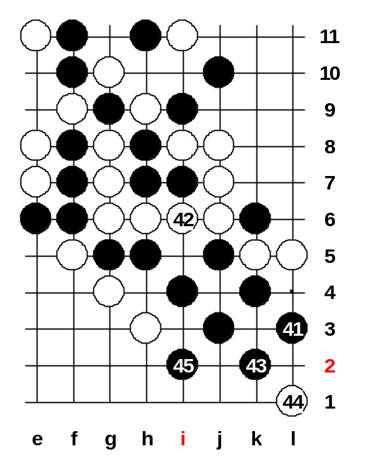
Problem 6: This position comes from the 5th game of the Match between Nakamura and me. At that time I missed the black win in the 41st move (I played 41-k10 at that time). In fact, black can win below.

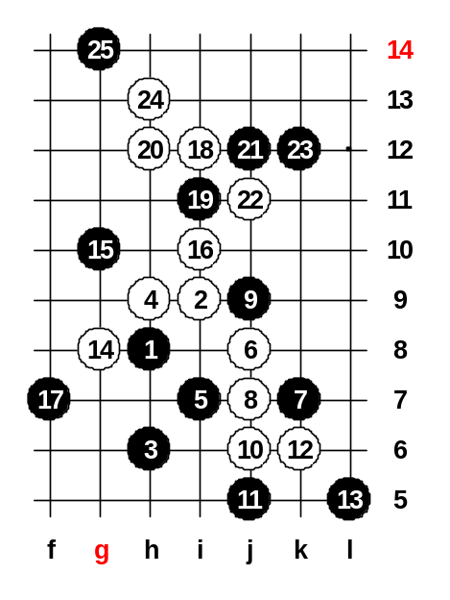
← Even though black seems to have lots of sources, there is not much space for the attack. However, moves 41, 43 and 45 give the way to victory despite the narrow space.

Problem 7: The sequence of moves is very natural. Black made a mistake in 17th move and white got a chance for sure win attack. Shown 21st move is the strongest resistance, even though it loses, too.

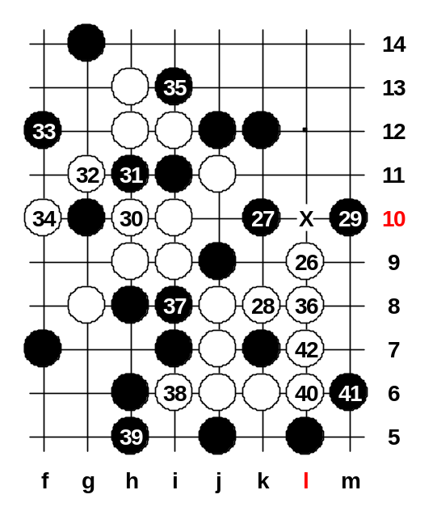
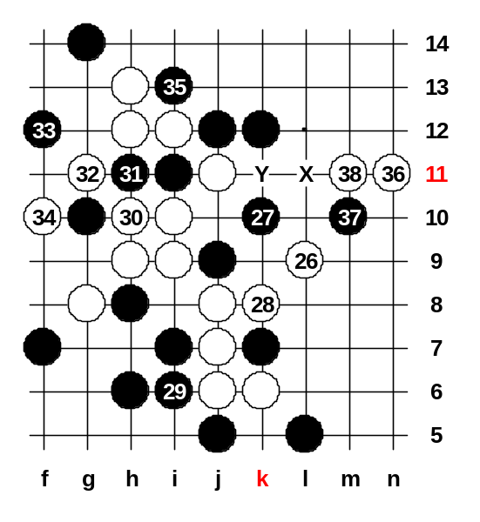

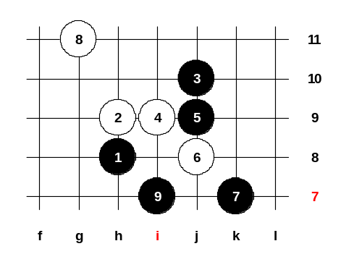
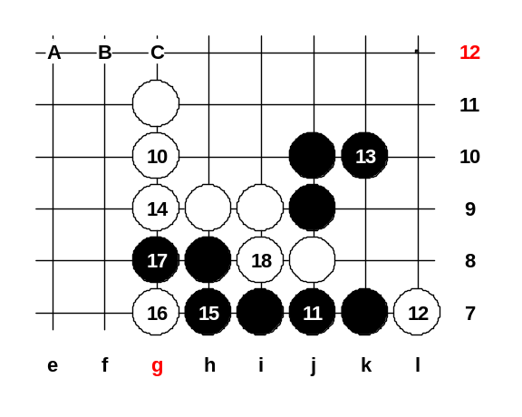
Problem 8: This gambling 8th move was popular in 5lin several months ago. Quite often a black player chose a mistaken 9th move. In this renju problem black chose one of the best 9th moves, but still not good enough because white has a wonderful idea how to win.

Since the passive defense is no use, black tries to play actively but white can cut black’s threat with moves 14 and 18 by making their own VCF threat A,B,C.

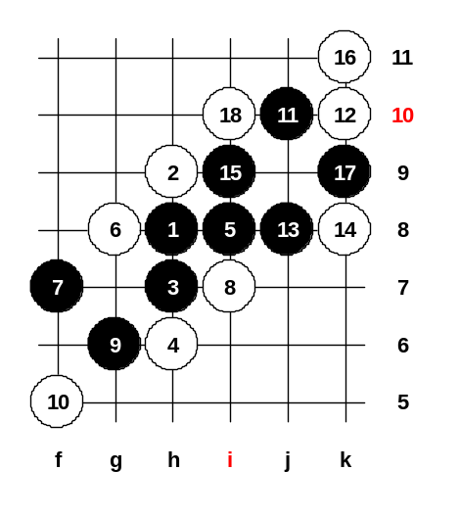

Problem 9: The d8 opening with the strongest 5th move has attracted many renju players all over the world. They always tried to study the ways of defense here and sometimes this 5th move was been played in renju tournaments. However, the advanced analysis has proved black win everywhere, including the position shown in this renju problem.

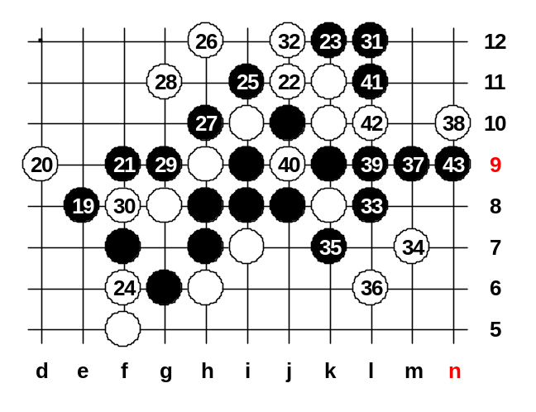
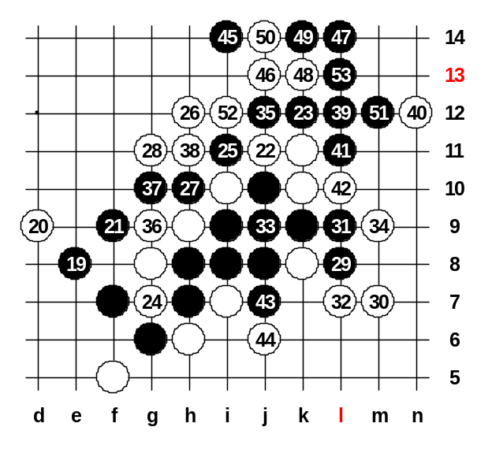
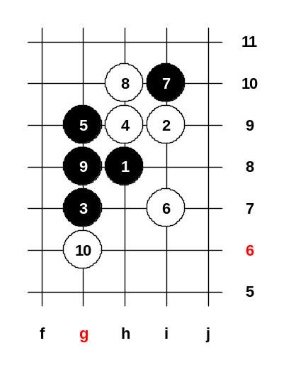
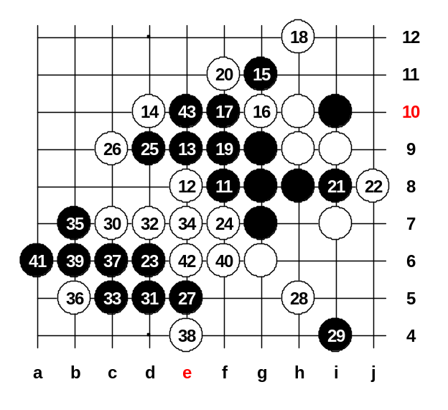
Problem 10: Although there are only few stones composing the 10th renju problem, the solution is not easy nor short. It is very hard to notice the end of the attack at point e10.

New renju problems.

Hereby we present the next 10 renju problems for you to solve. As usually, the first problems are easier whereas the last problems are more difficult.

Note that it is not easy to find the answers to all renju problems, the beginners will be able to solve about 2-3 problems, the medium level players about 4-8 problems. Solving all 10 problems will prove that your renju level is very good and you are very competitive in the world class.

Good luck in solving the renju problems!

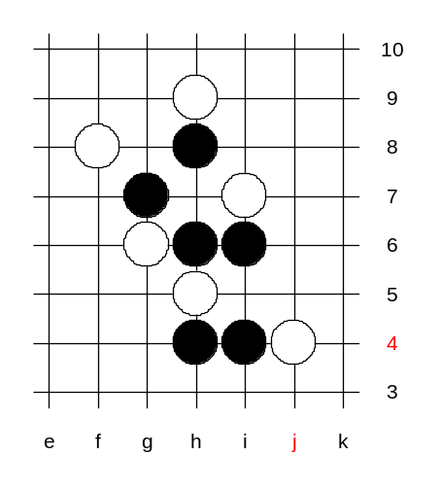
Problem 1:
Black wins. →

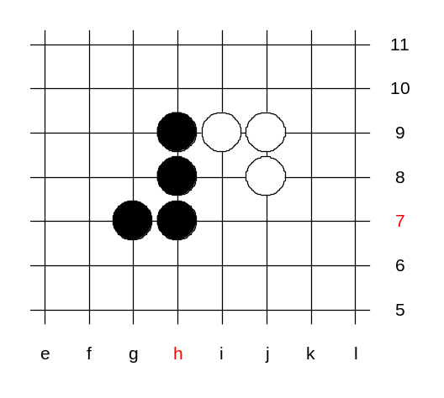
Problem 2:
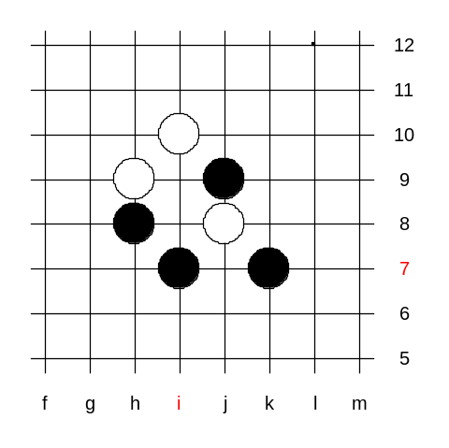
← White wins.

Problem 3:
White wins. →
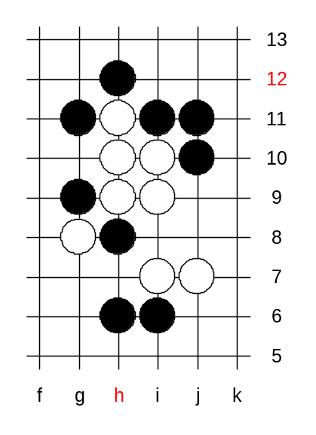

Problem 4:
← White wins.
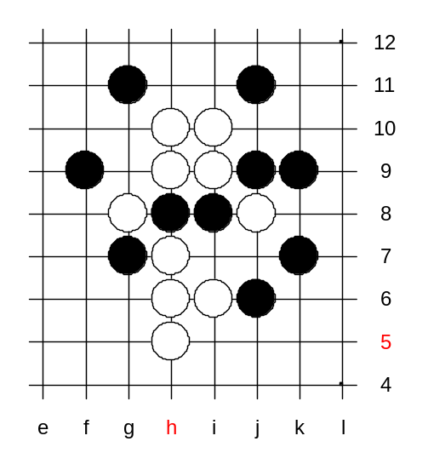

Problem 5:
Black wins. →

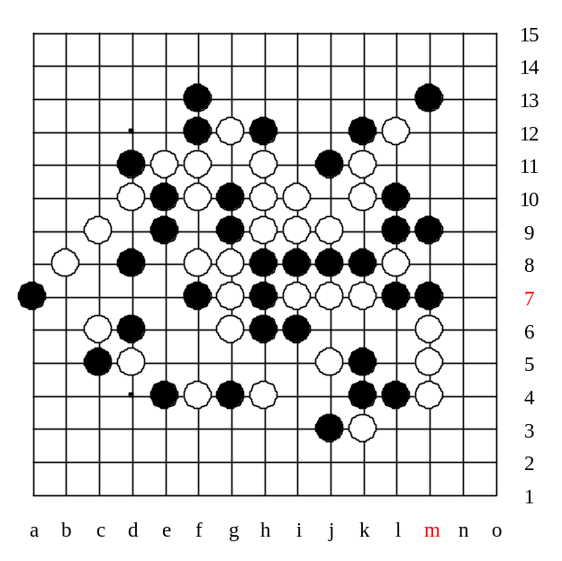

Problem 6:
White wins. →

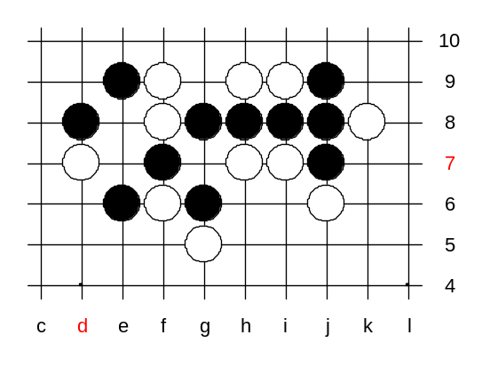
Problem 7:
← Black wins.
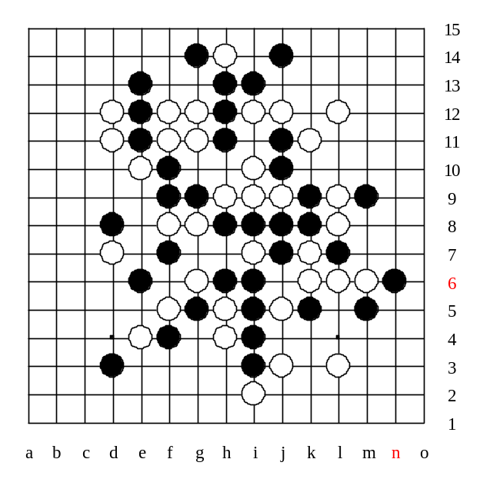

Problem 8:
White wins. →

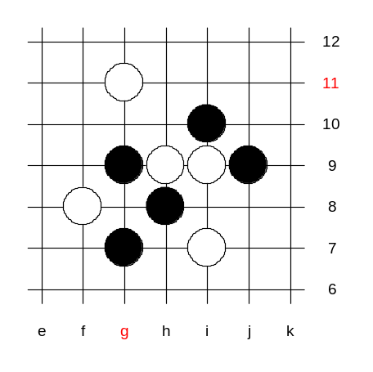
Problem 9:
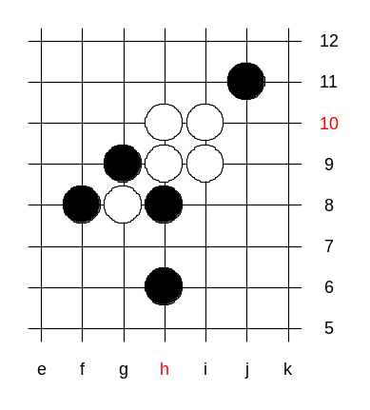
← Black wins.

Problem 10:
Black wins. →

